**Project Planning Phase**

**Sprint Delivery Plan**

|  |  |
| --- | --- |
| Date | 18 October 2022 |
| Team ID | PNT2022TMID14584 |
| Project Name | Customer Care Registry |
| Maximum Marks | 8 Marks |

Velocity:

Imagine we have a 10-day sprint duration, and the velocity of the team is 20 (points per sprint). Let’s calculate the team’s average velocity (AV) per iteration unit (story points per day)

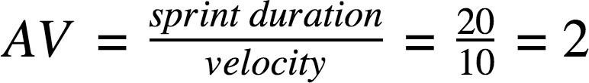

# Product Backlog, Sprint Schedule, and Estimation (4 Marks)

## Use the below template to create product backlog and sprint schedule

|  |  |  |  |  |  |  |
| --- | --- | --- | --- | --- | --- | --- |
| Sprint | Functional  Requirement (Epic) | User Story  Number | User Story / Task | Story Points | Priority | Team Members |
| Sprint-1 | User Panel | USN-1 | The user will login into the website and go through the  services available on the web page | 20 | High | Ilamvazhuthi J  Aswin venkat |
| Sprint-2 | Admin panel | USN-2 | The role of the admin is to check out the database about the availability and have a track of all the things that the users are going to service | 20 | High | Priyadharshan  Abhay Deep |
| Sprint-3 | Chat Bot | USN-3 | The user can directly talk to Chat bot regarding the services. Get the recommendations based on information provided by the user. | 20 | High | Ilamvazhuthi J  Priyadharshan |
| Sprint-4 | final delivery | USN-4 | Container of applications using docker kubernetes and deployment the application. Create the documentation and final submit the application | 20 | High | Ilamvazhuthi J  Aswin Venkat R  Abhay Deep |

# Project Tracker, Velocity & Burndown Chart: (4 Marks)

|  |  |  |  |  |  |  |
| --- | --- | --- | --- | --- | --- | --- |
| Sprint | Total Story Points | Duration | Sprint Start Date | Sprint End Date (Planned) | Story Points Completed (as on Planned End Date) | Sprint Release Date (Actual) |
| Sprint-1 | 20 | 6 Days | 24 Oct 2022 | 29 Oct 2022 |  | 29 Oct 2022 |
| Sprint-2 | 20 | 6 Days | 31 Oct 2022 | 05 Nov 2022 |  | 05 Nov 2022 |
| Sprint-3 | 20 | 6 Days | 07 Nov 2022 | 12 Nov 2022 |  | 12 Nov 2022 |
| Sprint-4 | 20 | 6 Days | 14 Nov 2022 | 19 Nov 2022 |  | 19 Nov 2022 |

**BURNDOWN CHART**

